INTERNSHIP PROJECT REPORT

Hands-On Data Lab
Implementation
Python · Jupyter Notebook · pandas · NumPy · Matplotlib · Seaborn

Data cleaning, manipulation, visualization, EDA and statistical analysis
Supermarket Sales Analysis (synthetic dataset)
Submitted by: | Lokesh Patwal
Course / Year: | B.Tech, 3rd Year
College / University: | Invertis University
Internship Provider: | Yuva Intern
Internship Period: | October 01, 2026 to November 26, 2026
Date of Submission: | 10 October 2026

Table of Contents
2. Certificate and Acknowledgement
3. Introduction
4. Problem Statement
5. Objectives
6. Tools and Technologies
7. Dataset Description
8. Methodology
9. Environment Setup
10. Data Loading
11. Data Cleaning
12. Data Manipulation
13. Exploratory Data Analysis
14. Data Visualization
15. Statistical Analysis
16. Results and Findings
17. Challenges
18. Learning Outcomes
19. Conclusion
20. Future Scope
21. References

2. Certificate and Acknowledgement

Certificate (placeholder)
This is to certify that Lokesh Patwal, a B.Tech 3rd-year student of Invertis University, has completed the project titled "Hands-On Data Lab Implementation" as part of the internship with Yuva Intern from October 01, 2026 to November 26, 2026. (Replace this text with the certificate or declaration format required by your college or by Yuva Intern, and add signatures if needed.)

Acknowledgement (placeholder)
I would like to thank Yuva Intern for giving me the opportunity to work on this project, and my college and family for their support. (Edit this paragraph in your own words.)

3. Introduction
Data analysis is the process of examining data to find useful information such as totals, averages, comparisons and trends, so that better decisions can be made. Organisations such as supermarkets create thousands of records every day, and tools such as Python make it possible to clean, summarise and visualise this data quickly.
This project, Hands-On Data Lab Implementation, builds a working data analysis environment using Python, Jupyter Notebook, pandas, NumPy, Matplotlib and Seaborn, and uses it to complete practical exercises on a supermarket sales dataset: data cleaning, data manipulation, exploratory data analysis (EDA), visualization and basic statistical analysis.

4. Problem Statement
A supermarket chain with three branches records every customer invoice, but the raw records contain data-entry problems and nobody has examined them. The problem addressed in this project is: how can we set up a Python data lab, clean the sales records and use data manipulation, visualization and basic statistics to understand sales performance (which products, branches, customers and times of day generate the most revenue, and whether customer ratings depend on spending)?

5. Objectives
- Set up a data science environment using Python, Jupyter Notebook and the required libraries.
- Complete practical exercises involving data manipulation, data visualization, exploratory data analysis and basic statistical analysis.
Specific goals: load and inspect a CSV dataset; detect and fix data-quality problems; answer 10 EDA questions; create 8 charts; calculate correlations and descriptive statistics; document at least 10 insights supported by the results.

6. Tools and Technologies
Tool | Purpose
Python 3 | Programming language for all code
Jupyter Notebook | Interactive document combining code, output and explanation
pandas | Tables (DataFrames), cleaning, filtering, grouping, aggregation
NumPy | Numerical calculations used by pandas and for checks
Matplotlib | Basic charts and saving figures
Seaborn | Statistical charts (histogram, box plot, heatmap, scatter plot)
Git and GitHub | Version control and sharing of the project

Tested versions: Python 3.12, pandas 3.0, NumPy 2.4, Matplotlib 3.10, Seaborn 0.13.

7. Dataset Description
Name: Supermarket Sales (synthetic version generated for this project).
Important
The dataset is synthetic. It was generated by the program src/generate_dataset.py with a fixed random seed. It is not real company data. Its column names and layout follow the public Kaggle Supermarket sales dataset (https://www.kaggle.com/aungpyaeap/supermarket-sales), which is described publicly as having 1000 rows and 17 columns for three branches during January to March 2019. This project does not use that real data and its results must not be presented as facts about a real supermarket.

Property | Value
File | data/dataset.csv
Raw size | 1006 rows x 17 columns
After cleaning | 1000 unique invoices x 15 columns (+ derived columns used in analysis)
Period | 01 January 2025 to 31 March 2025 (90 days)
Branches | A (Mumbai), B (Delhi), C (Bengaluru)
Currency | Rupees (Rs.)

Main columns: Invoice ID, Branch, City, Customer type (Member/Normal), Gender, Product line (6 categories), Unit price, Quantity, Tax 5%, Total, Date, Time, Payment (Cash/Credit card/Ewallet), cogs, gross margin percentage, gross income and Rating (1 to 10). The full data dictionary is in data/README.md.
Problems included on purpose (to give the cleaning stage real work): 12 blank ratings, 6 duplicate invoices and 8 different spellings of the 3 payment methods. In addition, Date and Time are stored as text, and two columns carry no extra information.

8. Methodology
The work followed the standard analysis workflow:
- Environment setup: Python, virtual environment, libraries, Jupyter.
- Data loading: read data/dataset.csv into a pandas DataFrame.
- Initial exploration: head, tail, shape, columns, info, describe, dtypes.
- Data quality checking: missing values, duplicates, data types, inconsistent values, range and formula checks, outliers.
- Data cleaning: fix the problems found, with before/after checks.
- Data manipulation: select, filter, sort, create columns, group and aggregate.
- EDA: answer 10 questions.
- Visualization: 8 charts saved as PNG files.
- Correlation and statistical analysis.
- Insights, conclusion and documentation.
The same workflow is implemented twice: as a step-by-step notebook (notebooks/Hands_On_Data_Lab.ipynb) and as a reusable script (src/analysis.py). Both give the same numbers.

9. Environment Setup
- Python 3 was installed from python.org (with "Add python.exe to PATH").
- A virtual environment was created with python -m venv venv and activated with venv\Scripts\activate.
- Libraries were installed with pip install -r requirements.txt (numpy, pandas, matplotlib, seaborn, jupyter, notebook).
- Jupyter Notebook was started with jupyter notebook and notebooks/Hands_On_Data_Lab.ipynb was opened and run.
The complete command list is in docs/Environment_Setup_Windows.md.

10. Data Loading
The notebook is located in the notebooks folder, so the dataset is read with the relative path ../data/dataset.csv:
Python code
df_raw = pd.read_csv("../data/dataset.csv")

The file loaded successfully with 1006 rows and 17 columns. Initial exploration showed that all columns have 1006 non-null values except Rating, that Date and Time are text, and that gross margin percentage has the same value in every row.

11. Data Cleaning
Problem found | Action taken | Result
6 duplicate invoices (same Invoice ID entered twice) | drop_duplicates() | 1006 rows reduced to 1000 rows
12 missing ratings | Filled with the median rating (7.0) | 0 missing values
Payment typed in 8 different ways | str.strip().str.capitalize() | 3 payment methods
Date and Time stored as text | pd.to_datetime() with explicit format; hour column extracted | Proper date type; date range 01 January 2025 to 31 March 2025
Column names with spaces and symbols | Renamed with a dictionary | e.g. Tax 5% became tax_5pct
gross margin percentage constant, gross income equal to Tax 5% | Columns dropped | 17 columns reduced to 15
24 high-value invoices (IQR rule) | Checked and kept: they are genuine large purchases | Reported in the statistics

After cleaning, validation checks confirmed unique invoice IDs, no missing values, quantities between 1 and 10, positive prices and ratings between 1 and 10.

12. Data Manipulation
The following pandas operations were demonstrated with meaningful examples: selecting columns; filtering rows with one or several conditions (for example Member invoices for Home and lifestyle, or evening Ewallet invoices); sorting (largest and smallest invoices); creating new columns (month, weekday, is_weekend, order_size using pd.qcut); value_counts(); aggregation with mean, median, min, max and sum; groupby() with named aggregations; and a pivot table (average invoice by branch and customer type).

13. Exploratory Data Analysis
Ten questions were answered with code in the notebook:
- Average invoice total: mean Rs. 2,776.99, median Rs. 2,277.04.
- Highest/lowest product line: Home and lifestyle and Food and beverages.
- Best branch: Branch C (Bengaluru).
- Most common categories: payments almost equally split.
- Distribution of totals: right-skewed (skewness 1.05).
- Trend over time: no clear growth; revenue per day is flat.
- Busiest hours and days: 19:00 (Rs. 427,927), 18:00 (Rs. 359,141) and 13:00 (Rs. 339,386); weekends.
- Members vs Normal customers; Female vs Male customers.
- Best branch and product-line combination: Branch C - Home and lifestyle (Rs. 246,426).
- Ratings versus spending and product line: no relationship.

14. Data Visualization
Eight charts were created (all saved in the visualizations folder); each has a title and labelled axes, and a legend where several groups are shown.
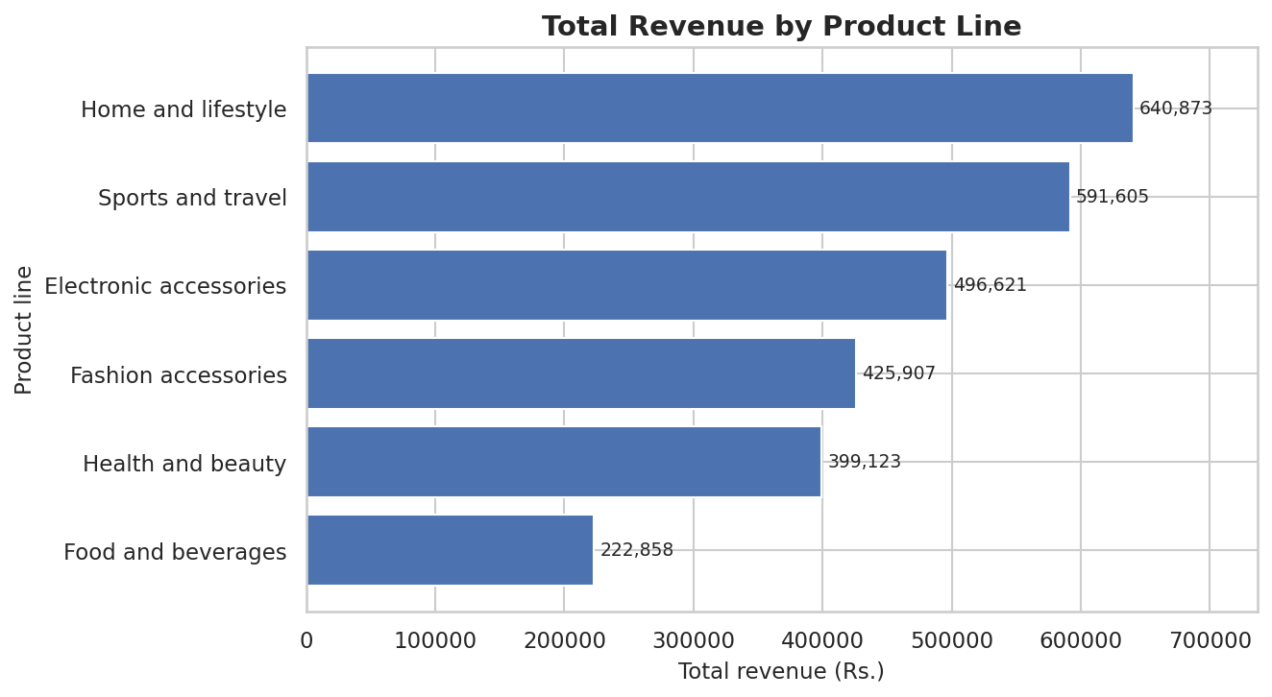
Figure 1: Total revenue by product line (bar chart)
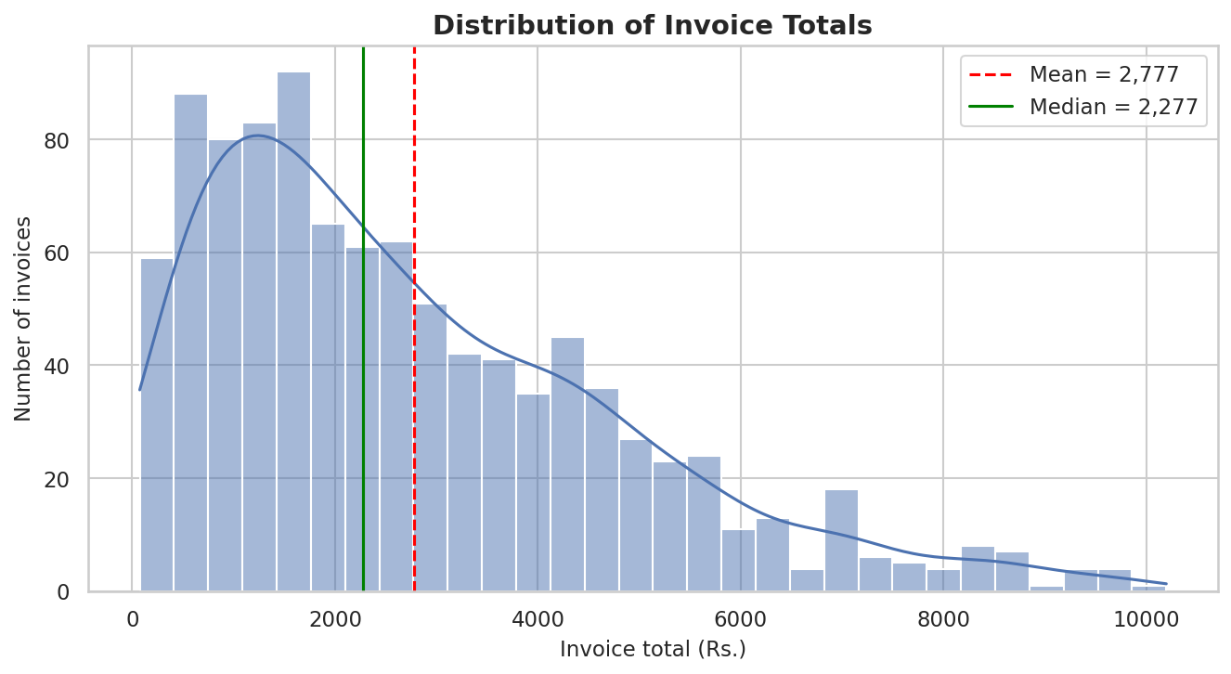
Figure 2: Distribution of invoice totals (histogram)
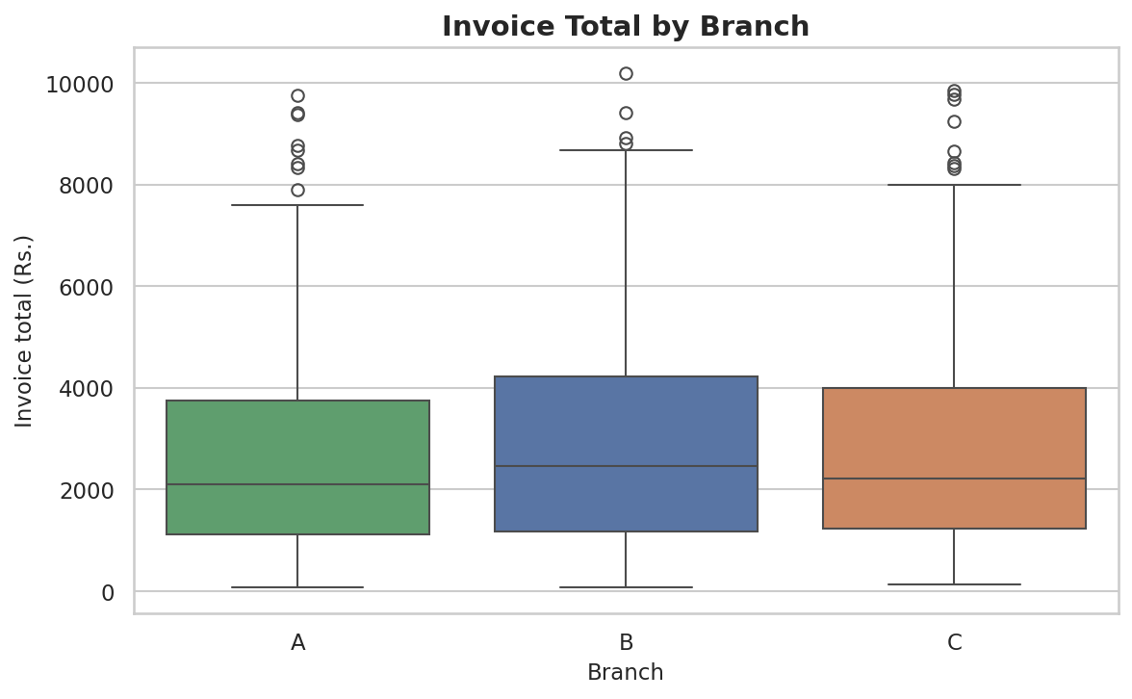
Figure 3: Invoice total by branch (box plot)
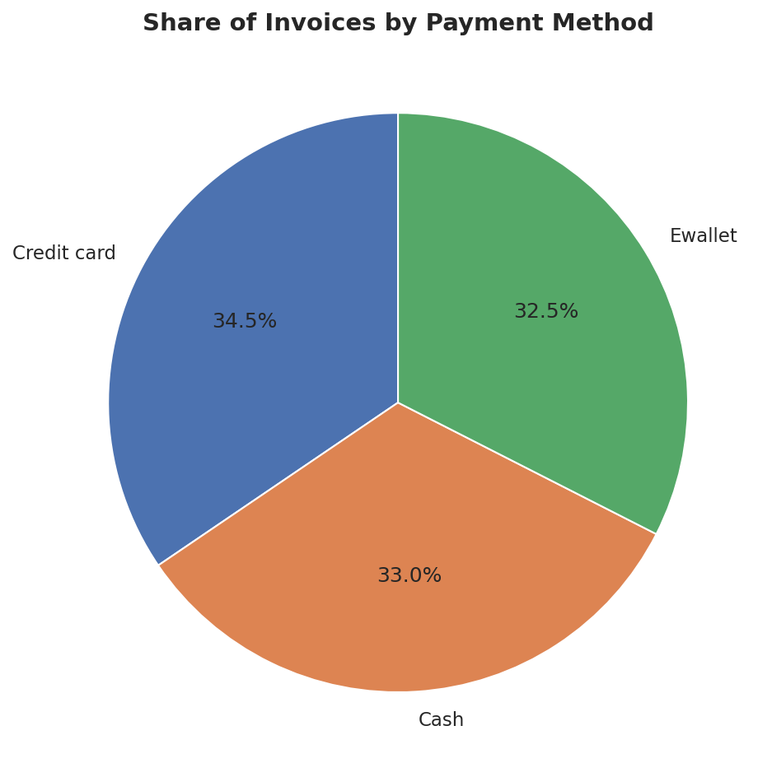
Figure 4: Share of invoices by payment method (pie chart)
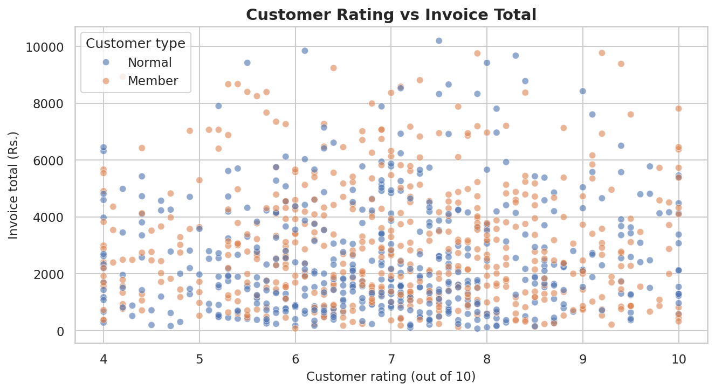
Figure 5: Customer rating vs invoice total (scatter plot)
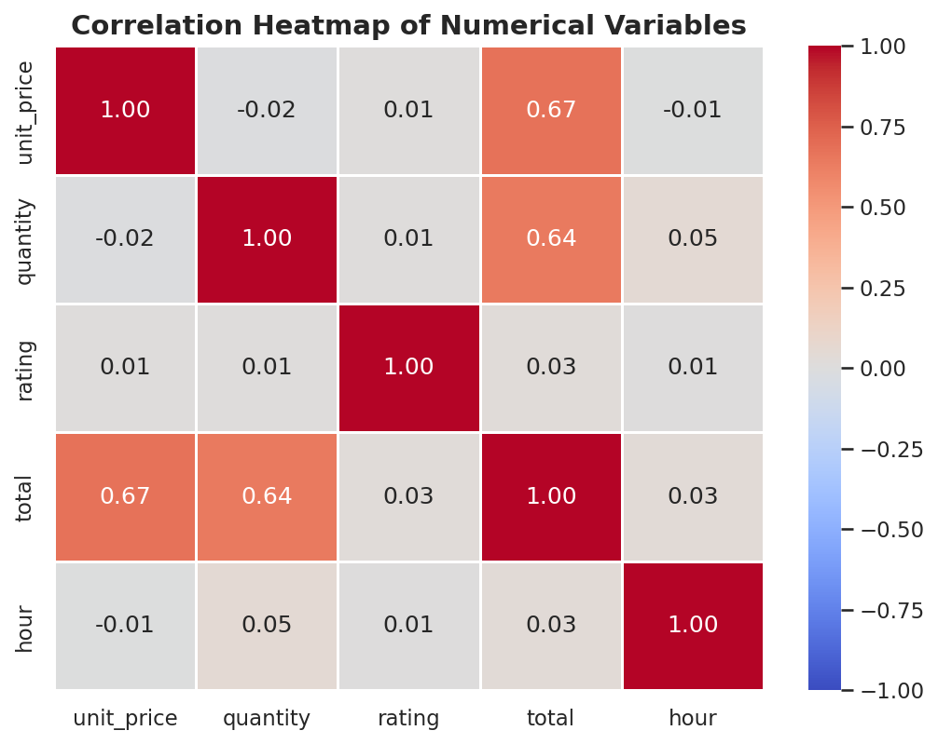
Figure 6: Correlation heatmap
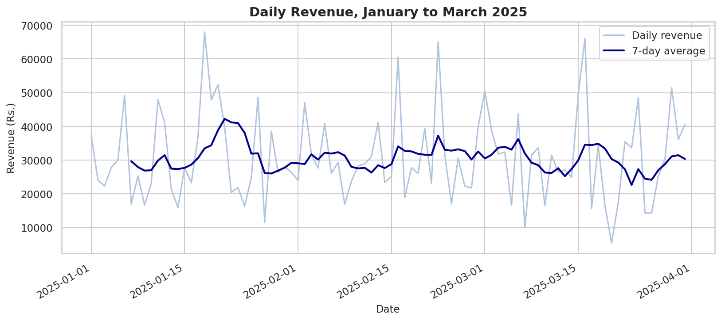
Figure 7: Daily revenue with 7-day average (line chart)
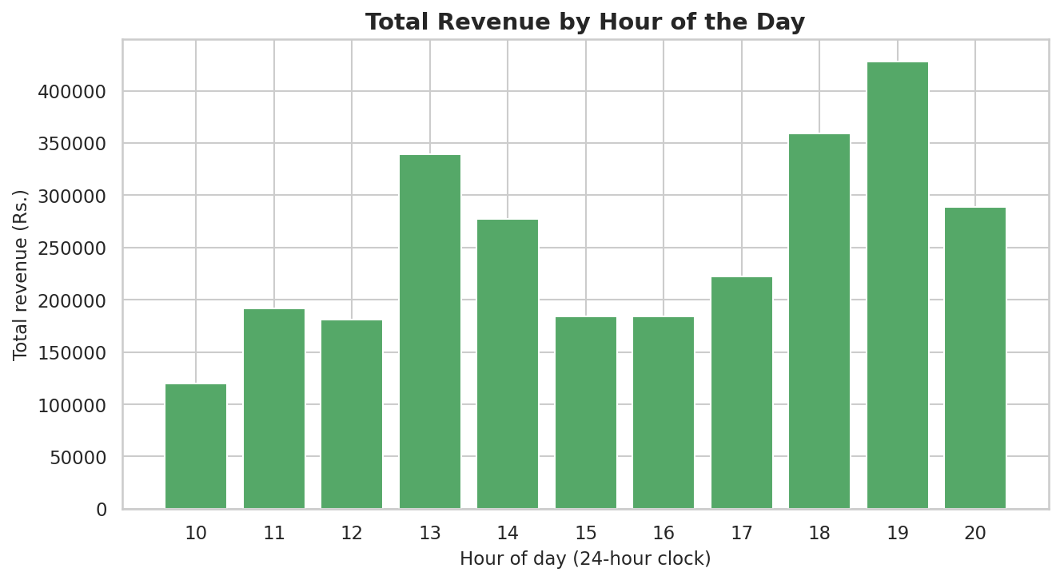
Figure 8: Total revenue by hour of the day (bar chart)
Summary of what the charts show: product lines with higher prices earn more (Figure 1); invoice amounts are right-skewed (Figure 2); branches look similar (Figure 3); payment methods are used equally (Figure 4); rating and spending are unrelated (Figure 5); total depends on price and quantity (Figure 6); daily revenue has no lasting trend (Figure 7); there are lunchtime and evening peaks (Figure 8).

15. Statistical Analysis
Statistic (invoice total) | Value
Mean | Rs. 2,776.99
Median | Rs. 2,277.04
Standard deviation | Rs. 2,053.01
Minimum / Maximum | Rs. 74.06 / Rs. 10,196.66
Q1 (25%) / Q3 (75%) | Rs. 1,179.42 / Rs. 4,007.49
IQR | Rs. 2,828.07
Outlier limit (Q3 + 1.5 x IQR) | Rs. 8,249.59 (25 invoices above it)
Skewness | 1.05 (right-skewed)

Correlations (Pearson): total vs unit price 0.67; total vs quantity 0.64; unit price vs quantity -0.02; rating vs total 0.03; hour vs total 0.03. The high values for price and quantity exist because the invoice total is calculated from them. Correlation does not prove causation.
Rating: mean 7.02, standard deviation 1.49.

16. Results and Findings
Revenue by product line
Product line | Revenue | Share | Invoices | Average invoice
Home and lifestyle | Rs. 640,873 | 23.1% | 158 | Rs. 4,056
Sports and travel | Rs. 591,605 | 21.3% | 176 | Rs. 3,361
Electronic accessories | Rs. 496,621 | 17.9% | 155 | Rs. 3,204
Fashion accessories | Rs. 425,907 | 15.3% | 174 | Rs. 2,448
Health and beauty | Rs. 399,123 | 14.4% | 173 | Rs. 2,307
Food and beverages | Rs. 222,858 | 8.0% | 164 | Rs. 1,359

Revenue by branch
Branch | City | Revenue | Invoices | Average invoice
C | Bengaluru | Rs. 965,691 | 345 | Rs. 2,799
B | Delhi | Rs. 960,257 | 332 | Rs. 2,892
A | Mumbai | Rs. 851,038 | 323 | Rs. 2,635

Payment methods
Method | Invoices | Share
Credit card | 345 | 34.5%
Cash | 330 | 33.0%
Ewallet | 325 | 32.5%

Revenue by day of week
Day | Revenue
Monday | Rs. 383,344
Tuesday | Rs. 338,388
Wednesday | Rs. 331,343
Thursday | Rs. 343,794
Friday | Rs. 323,194
Saturday | Rs. 517,992
Sunday | Rs. 538,931

Key findings
- Total revenue is Rs. 2,776,985.72 from 1000 invoices in 90 days; the average invoice (Rs. 2,776.99) is above the median (Rs. 2,277.04) because a few large invoices pull it up.
- Home and lifestyle earns the most (23.1% of revenue) and Food and beverages the least (8.0%); the difference comes from price, since invoice counts per product line are similar (155 to 176).
- Branch C (Bengaluru) leads and Branch A (Mumbai) is 12% lower; the branches are fairly close.
- Payment methods are used equally.
- Members spend 19% more per invoice (Rs. 3,008 vs Rs. 2,529) because they buy more items (6.30 vs 5.35).
- Busiest hours: 19:00 (Rs. 427,927), 18:00 (Rs. 359,141) and 13:00 (Rs. 339,386).
- Saturday and Sunday contribute 38.1% of revenue (average Rs. 40,651 per weekend day against Rs. 26,876 per weekday).
- Revenue per day is almost constant from January to March; February is lower only because it has 28 days.
- Ratings do not depend on spending (correlation 0.03).
- Cleaning was necessary: without it, 6 duplicate invoices would have inflated revenue and the payment counts would have been wrong.
These findings describe the synthetic dataset only.

17. Challenges
(Edit this section so that it describes the difficulties you really faced.)
- Understanding the data types: Date was stored as text and had to be converted using the correct format (month/day/year) before months and hours could be extracted.
- Finding hidden problems: the payment column looked fine at first; value_counts() revealed 8 spellings of 3 methods, and duplicates had to be checked with both duplicated() and the Invoice ID.
- Deciding what to do with outliers and missing values: large invoices were genuine, so they were kept; blank ratings were filled with the median.
- Interpreting results correctly: the mean was misleading for skewed data, February seemed to have lower sales only because it is shorter, and high correlation between total and price is a result of the formula, not a discovery.
- File paths: the notebook and script are in different folders, so relative paths (../data/dataset.csv) and path handling with pathlib were needed.

18. Learning Outcomes
- Set up a Python data-analysis environment on Windows (virtual environment, pip, Jupyter).
- Load and inspect CSV data with pandas.
- Detect and fix missing values, duplicates, inconsistent text, wrong data types and redundant columns.
- Select, filter, sort, group and aggregate data.
- Perform EDA by asking and answering questions with code.
- Create and interpret bar charts, histograms, box plots, pie charts, scatter plots, heatmaps and line charts.
- Calculate and explain mean, median, mode, standard deviation, quartiles, skewness and correlation.
- Write clear, evidence-based insights and organise a project in a GitHub-ready structure.

19. Conclusion
The project successfully set up a working data lab and completed the required practical exercises: 1006 raw records were cleaned to 1000 reliable invoices, manipulated with pandas, explored through 10 questions, visualised with 8 charts and summarised with statistics and correlations. The analysis showed that revenue depends mainly on product price and quantity, that Members buy more items, that business is concentrated at lunchtime, in the evening and on weekends, and that customer ratings are unrelated to spending. Python and its libraries made each step fast, repeatable and easy to explain. The main limitation is that the dataset is synthetic, so the findings are a demonstration of the method and not conclusions about a real business.

20. Future Scope
- Repeat the analysis on a real, larger dataset (for example the Kaggle Supermarket sales data or several years of real sales).
- Add machine learning (optional): predict invoice totals or group customers by clustering.
- Forecast daily revenue to plan stock and staff.
- Build an interactive dashboard (Streamlit, Plotly Dash, Power BI or Tableau).
- Connect to a live database for real-time data.
- Use hypothesis tests and confidence intervals (for example Member vs Normal customers).

21. References
- Python Software Foundation. Python 3 Documentation. https://docs.python.org/3/
- The pandas development team. pandas Documentation. https://pandas.pydata.org/docs/
- NumPy Developers. NumPy Documentation. https://numpy.org/doc/
- Matplotlib Development Team. Matplotlib Documentation. https://matplotlib.org/stable/
- Waskom, M. L. seaborn: statistical data visualization. https://seaborn.pydata.org/
- Project Jupyter. Jupyter Notebook Documentation. https://jupyter-notebook.readthedocs.io/
- Git. Git Documentation. https://git-scm.com/doc
- McKinney, W. (2022). Python for Data Analysis (3rd ed.). O'Reilly Media.
- Aung Pyae. Supermarket sales (Kaggle dataset; layout reference only, not used for results). https://www.kaggle.com/aungpyaeap/supermarket-sales

